Division of Community and Public Health - Director’s Office
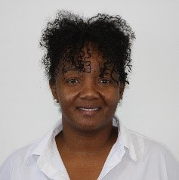
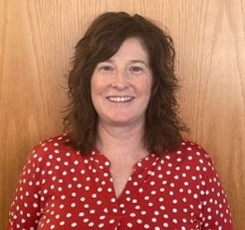
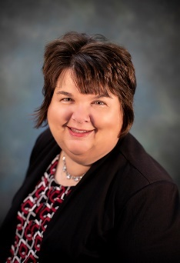
Mindy Laughlin Deputy Director (573) 751-6432
Alicia Jenkins
Deputy Director
(573) 751-1152
Lori Brenneke
Director
(573) 751-1928
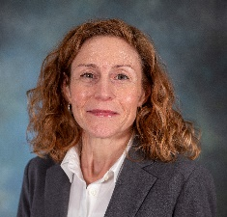


Pat Simmons
Assistant Deputy
(573) 526-1822
Venkata Garikapaty
Assistant Deputy
(573) 526-0452
Jonathan Garoutte
Assistant Deputy
(573) 751-6079

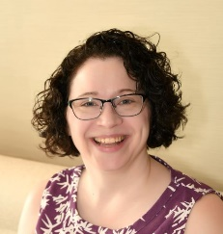
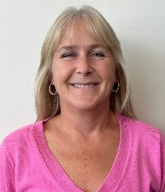
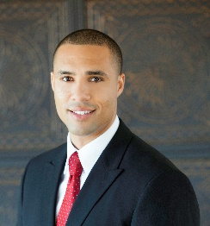
Stacy Kempker
Executive Assistant
(573) 751-6080
Christine Knight
Operations Assistant
(573) 526-0219
Seth Bauman
Assistant Deputy
(573) 522-2802
Division Operations Unit  Office of Financial and Budget Services (OFABS)  (573) 526-0219  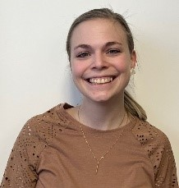  Maddie Starnes, Operations Director  (573) 526-7712  DCPH Special Projects Unit    Patrick Cosby,  (573) 522-8329  Public Health Information Network (PHIN)  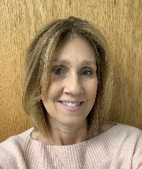  Susan Dulle  (573) 526-4276 | - Purchasing  - Payment Processing  - Timekeeping (DELTA) Oversight  - Training on Fiscal Management Leadership and Oversight of fiscal management systems  - Continuity of Operations  - Fiscal Estimates for Legislation (Fiscal Notes)  - Preparation of Annual State Budget Request  - Legislative Proposals  - Collaborates with stakeholders to develop interoperability connections  - Ensure IT project completion
Maternal Child Health Leadership  (573) 751-6168  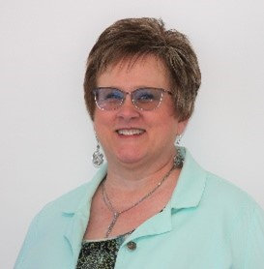  Martha Smith, Chief  (573) 751-6435  Kyle Jenkins,  Lead Support  (573) 751-6168 | - Family & Community Engagement & Partnership  - Fetal and Infant Mortality Review (FIMR)  - Health, CYSHCN, & Cross-cutting MCH  - Leadership & Oversight of Overarching State MCH Efforts, Programming and Initiatives  - Maternal Mortality Prevention Plan (MMPP)  - Medical Home  - MCH Learning Community  - MCH Needs Assessment  - MCH State Action Planning: Women & Maternal Health, Perinatal & Infant Health, Child Health, Adolescent, CYSHCN and Cross-cutting MCH  - MCH Systems  - MCH Workforce  - MO Maternal Health Action Network  - MO MCH Alliance  - MO Title V MCH Services Block Grant Program  - Public Health Nursing (DHSS Liaison with MPHA Section for Public Health Nursing)  - State Adolescent Health Leader & Youth Voices
Center for Local Public Health Services (CLPHS)  (573) 751-6170  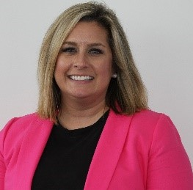  Tiffany Bayer, Chief  (573) 522-2874  Jackie McCoy,  Lead Support  (573) 751-6170 | Webpage - https://health.mo.gov/living/lpha/  - CHIP H.S.I.  - Core Participation Agreements  - New LPHA Administrator and Board of  - Health Administrator Orientation  - PHIG Grant  - Technical Assistance and Linkage for LPHAs

Division of Administration - Director’s Office
Alicia Jenkins
Deputy Director
(573) 751-1152

Bureau of Community Food and Nutrition Assistance (CFNA)  (573) 751-6269  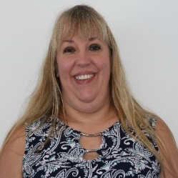  Sarah Walker, Chief  (573) 751-6256  Larissa Wehmeir, Lead Support  (573) 751-6269 | Toll Free: 800-733-6251  Email @ CACFP@health.mo.gov  Webpage - https://health.mo.gov/living/wellness/nutrition/foodprograms/cacfp/index.php  Toll Free: 888-435-1464  Email @ SFSP@health.mo.gov  Webpage - https://health.mo.gov/living/wellness/nutrition/foodprograms/sfsp/index.php  - Child & Adult Care Food Program (CACFP)  - Commodity Supplemental Food Program (CSFP)  - Summer Food Service Program (SFSP)
Bureau of WIC and Nutrition Services (WICNS)  (573) 751-6204  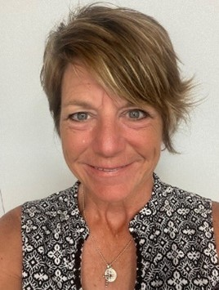  Angie Oesterly, Chief  (573) 522-6266  Dora Crawford,  Lead Support  (573) 751-6265 | Toll Free: 800-392-8209  MOWINS Help Desk: 800-554-2544  Email WICNS @ WICinfo@health.mo.gov  Webpage https://health.mo.gov/living/families/wic/families/howdoiapplyforwic/  - Breastfeeding Peer Counseling  - Breastfeeding Program  - Supplemental Nutrition Program for Women, Infants and Children (WIC)

Division of Community and Public Health - Director’s Office
Alicia Jenkins
Deputy Director
(573) 751-1152
Pat Simmons
Assistant Deputy
(573) 526-1822

Bureau of Cancer and Chronic Disease Control (CCDC)  (573) 522-2806  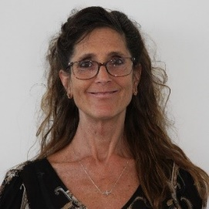  Sandy Hentges, Bureau Chief  (573) 522-2862  Angela Hammen, Lead Support  (573) 522-2806 | Webpage - https://health.mo.gov/living/healthcondiseases/chronic/  Organ Donor Toll Free: 888-497-4564  Email OD @ OrganDonor@health.mo.gov  Webpage - https://health.mo.gov/living/organdonor/  - ALS  - Alzheimer’s Prevention  - Arthritis and Osteoporosis  - Asthma Prevention and Control  - Comprehensive Cancer Control  - Diabetes Prevention and Control  - Heart Disease  - Organ Donor Program  - Show-Me Healthy Women (Breast and Cervical Cancer Control)  - WISEWOMAN
Bureau of Community Health and Wellness (CHW)  (573) 522-2820  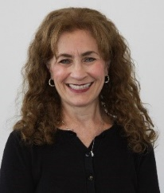  Valerie Howard, Chief  (573) 522-8299  Susan Demsko, Lead Support  (573) 522-2820 | Adolescent and School Health Program  - Personal Responsibility Education Program  - Positive Youth Development  - Sexual Risk Avoidance  - Tate School Nurse Consultant  Building Communities for Better Health  Injury and Overdose Prevention and Response  - OD2A  - MO-CORP  - Cannabis grant program  - Harm Reduction  - Safe Kids Coalition  MCH Services Program  Missouri Tobacco Prevention and Control Program  Physical Activity and Nutrition Program  Worksite Wellness
Office of Dental Health (ODH)  (573) 751-5874  Vacant, Chief  (573) 751-6395  Dione Snitker,  Lead Support  (573) 751-5874 | - Community Water Fluoridation – Education, Training & Support  - Dental Health Education  - Dental Health Workforce Issues  - Elks Mobile Dental and Donated Dental Program  - Improving Oral Health Outcomes  - Schools Preventive Services Program and Dental  - Sealant Program for MO Children  - Teledentistry
Office of Rural Health and Primary Care (ORHPC)  (573) 751-6441    Aleesha Jones, Chief  (573) 526-1024  Rain Davis,  Lead Support  (573) 751-6441 | Email: ORHPCinfo@health.mo.gov  Email: DHSS.LoanReplayment@health.mo.gov  - Community-Based Faculty Preceptor Tax Credit Program  - Delta Region Community Health Systems Development Program  - Health Professional Loan Repayment Program (HPLRP)  - Health Professional Shortage Areas (HPSAs) and Provider Management  - J-1 Visa and National Interest Waivers  - Missouri Graduate Medical Education (GME) Grant Program  - Missouri Health Professional Placement Services (MHPPS) Program  - Medicare Rural Hospital Flexibility Program  - Rural Health Care Provider Transition Project  - Rural Health Promotion and Blog  - Rural Primary Care Physician Grant Program  - Rural Recruitment and Retention Programs (3RNET)  - Small Rural Hospital Improvement Program  - State Office of Primary Care  - State Office of Rural Health  - Student Loan Repayment Program (SLRP)

Division of Administration - Director’s Office
Seth Bauman
Assistant Deputy
(573) 522-2802
Alicia Jenkins
Deputy Director
(573) 751-1152

Office of Minority Health and Health Equity (OMHHE)  (800) 877-3180  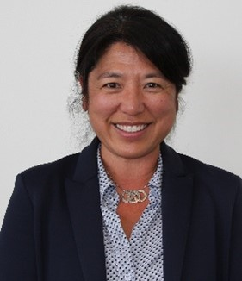  Angel Surdin, Chief  (573) 526-3276  Vacant, Lead Support (573) 751-1275 | Toll Free: 800-877-3180  - Minority Infant Mortality Prevention Initiative  - Obesity Prevention  - Promoting Healthy Minority
Bureau of HIV, STI and Hepatitis (BHSH)  (573) 751-6475    Dustin Hampton, Chief  (573) 751-6431  Renee Luebbering, Lead Support  (573) 751-6475 | Toll Free: 888-252-8045  - AIDS Drug Assistance Program (ADAP)  - Ending the HIV Epidemic Initiatives (EHE) – Consider listing  - as “EHE Initiatives”  - Hepatitis C Prevention, Testing and Health Education  - HIV/STD Screening, Testing and Prevention Services  - Housing Opportunities for Persons with AIDS (HOPWA) Program –  - Consider listing as “HOPWA Program”  - Medicaid AIDS Waiver  - Pre-exposure Prophylaxis (PrEP) Coordination – Consider listing as “PrEP Coordination  - Ryan White HIV Case Management
Bureau of Genetics and Healthy Childhood (GHC)  (573) 751-6266  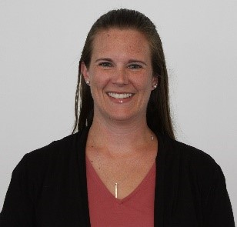  Jami Kiesling, Chief  (573) 522-9148  Dee Distler,  Lead Support  (573) 751-6214 | Toll Free: 800-877-6246  Webpage - https://health.mo.gov/living/families/genetics/  - Adult Genetics (Cystic Fibrosis, Hemophilia, and Sickle Cell Anemia)  - Genetic Services  - Metabolic Formula Distribution  - Newborn Health  - Newborn Hearing Screening  - Newborn Blood Spot Screening  - Prenatal Hepatitis B Prevention and Case Management  - Prenatal Substance Use Prevention  - Sexual Assault Forensic Examination and Child Abuse Resource and Education (SAFE-CARE)  - Sickle Cell Anemia  - SIDS Autopsy Reimbursement  - TEL-LINK
Office on Women’s Health (OWH)  (573) 522-2806    Sarah Ehrhard Reid, Chief  (573) 522-2833  Allie Jenkins,  Lead Support  (573) 751-7479 | - Baby and Me Tobacco Free Program-Telehealth  - Cora Faith Walker Doula Training Program  - Doula Services of Springfield  - Extended Women’s Health Services  - Maternal Autopsy Reimbursement  - Maternal Mortality / PAMR / Perinatal Quality Collaborative  - Maternal Neonatal Levels of Care  - Pregnancy Assistance Information  - Prenatal Care Clinic in Kansas City  - Sexual Assault Forensic Exams via Telehealth Statewide Network (SAFE-T Network)  - Sexual Violence Prevention  - Women’s Health Council  - Women’s Health Initiatives

Division of Community and Public Health - Director’s Office
Mindy Laughlin Deputy Director (573) 751-6432

State Epidemiologist
10-01-23
10-01-23
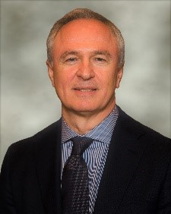
Dr. George Turabelidze
(314) 877-2826

Bureau of Immunizations (BI)  10-01-23  10-01-23  (573) 751-6124  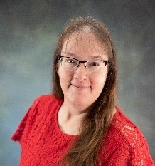  Lynelle Paro, Chief  (573) 526-7967  Beth Ott,  Lead Support  (573) 526-7688 | Toll Free: 800-219-3224  Email BI @ Immunizations@health.mo.gov  ShowMeVax Helpdesk: 866-256-3166  Email VFC @ vfc-smvsupport@health.mo.gov  Webpage - https://health.mo.gov/living/wellness/immunizations/  - Immunizations / Vaccines  - Immunizations Quality Improvement for Providers (IQIP)  - School & Child Care Survey Reporting  - Section 317 Vaccine  - ShowMeVax (Immunization Registry)  - Vaccines for Children
Bureau of Vital Records (BVR)  (573) 751-6387    Dylan Bryant, Chief  (573) 526-1511  Jonathan Wingate, Lead Support  (573) 526-0348 | Email BVR @ VitalRecordsInfo@health.mo.gov  Webpage - Bureau of Vital Records | Health & Senior Services (mo.gov)  - Adoptions  - Births  - Deaths  - Delayed Births  - Dissolutions of Marriage  - Foreign Born Adoptions  - Induced Termination of Pregnancies (ITOPs)  - Legitimations  - Applications/Reports of Marriage  - Missouri Adoptee Rights Act (Pre-Adoptive Requests)  - Paternity Affidavits  - Presumptive Deaths  - Putative Father Registry  - Reports of Fetal Death  - Statements of Single Status  - Surrogacies

Division of Community and Public Health - Director’s Office
Venkata Garikapaty
Assistant Deputy
(573) 526-0452
Mindy Laughlin Deputy Director (573) 751-6432

Health Informatics Unit Operations Manager  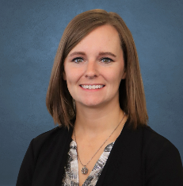  Johna Trapani  (573) 526-6660  Office of Epidemiology (OOE)  (573) 751-6272  Venkata Garikapaty, Chief  (573) 526-0452  Kelsi Kimbrel,  Lead Support  (573) 751-6272  Bureau of Health Care Analysis and Data Dissemination (BHCADD)  (573) 522-2808  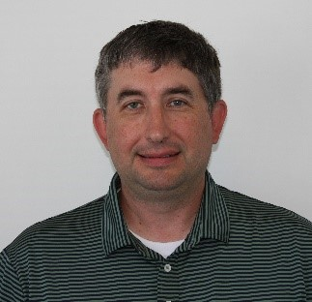  Andrew Hunter, Chief  (573) 526-0444  Tara Snellen,  Lead Support  (573) 522-2806  Bureau of Data Modernization & Interoperability (DMI)  (573) 522-2808  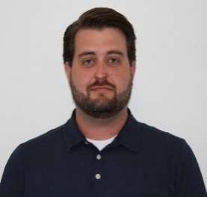  Zach Kempf, Chief  (573) 522-4360  Tara Snellen,  Lead Support  (573) 522-2806 | Epidemiology Teams:  - Chronic Disease  - Maternal Child Health  - Communicable Disease  - Cancer and Infrastructure  Surveillance Systems:  - Behavioral Risk Factor Surveillance System (BRFSS)  - County Level Study (CLS)  - Missouri Cancer Registry (MCR)  - National Violent Death Reporting System (NVDRS)  - Pregnancy Risk Assessment Monitoring System (PRAMS)  - Youth Risk Behavior Surveillance System (YRBS)  Surveillance and Reporting of:  - HIV, STDs and TB  - Maternal Mortality / Morbidity  - Other Communicable Diseases  - Vaccine Preventable Diseases  - Zoonotic Diseases  - Birth Defects Surveillance  - Drug Overdose Surveillance  - Healthcare-Associated Infection Reporting  - Inpatient and Outpatient Data  - MOPHIMS (MICA and Community Data Profiles)  - Syndromic Surveillance (ESSENCE)  - Vital Statistics (Birth, Death, Marriage, Abortion)  - Data Governancy / Infrastructure  - Data Systems Enhancements / Upgrades  - Develop interoperability within DCPH Systems  - Electronic Case Reporting  - Electronic Lab Reporting  - EpiTrax  - Immunization Information Systems  - Monitoring Reporting Compliance  - Show MeVax  - ShowMe WorldCare  - WebSurv

Division of Community and Public Health - Director’s Office
Jonathan Garoutte
Assistant Deputy
(573) 751-6079
Mindy Laughlin Deputy Director (573) 751-6432

Bureau of Communicable Disease Control and Prevention (CDCP)  (573) 751-6113  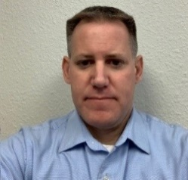  John Bos, Chief  (417) 895-6945  Sandy Betros, Lead Support (573) 751-6268 | Main Line: 573-751-6113  Webpage - https://health.mo.gov/living/healthcondiseases/communicable/  - Communicable Disease Investigation and Control  - Tuberculosis Elimination Program  - Zoonotic Diseases Program
Bureau of Environmental Epidemiology (BEE)  (573) 751-6102    Jeff Wenzel, Chief  (573) 522-2101  Brayden Bollwinkel, Lead Support  (573) 526-4911 | Toll Free: 888-837-0927  - Environmental Surveillance  - Environmental Public Health Tracking (EPHT)  - Health and Risk Assessment Program (HRAP)  - Healthy Indoor Environments  - Childhood Lead Poisoning Prevention Program (CLPPP)  - Healthy Drinking Water Unit  - Get the Lead out of Schools (GLOS)  - Private Drinking Water program  - Lead Licensing Program  - Wastewater Surveillance Program
Bureau of Environmental Health Services (BEHS)  (573) 751-6095  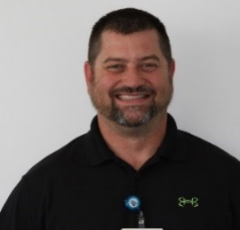  Dusty Johnson, Chief  (573) 751-8415  Charlene Smith, Lead Support  (573) 751-2483 | Toll Free: 888-435-1464  Email @ RetailFood@health.mo.gov  Webpage - https://health.mo.gov/safety/foodsafety/index.php  - Emergency Response to Natural Disasters and Emergency Situations  - Environmental Child Care Sanitation Inspections  - Environmental Investigations for Communicable Diseases  - Legionella Control and Prevention Assessments  - Lodging Licensing and Health/Safety Inspections  - Manufactured Food Facility Safety Inspections  - On-Site Waste Water Treatment Training and Evaluations  - Retail Food Safety Training and Inspections
Disease Control and Environmental Operations Manager  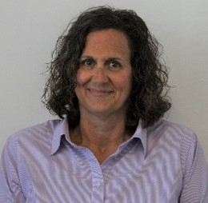  Dawn Wall  (573) 751-7715  Sandy Betros, Lead Support (573) 751-6268  Healthcare Associated Infections/Antimicrobial Resistance Program (HAI/AR)  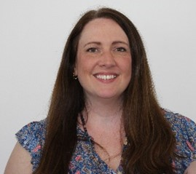  Amy Pierce, Coordinator  (573) 751-6268  Sandy Betros, Lead Support (573) 751-6268 | - Antimicrobial Stewardship  - Infection Prevention and Response  - Infection Control Breaches and Outbreaks  - Multi-drug resistant organisms

sect

Lori Brenneke, Division Director (573) 751-6080
Stacy Kempker, Executive Assistant
Operations Director & OFABS  (573) 526-0219 Maddie Starnes, Chief |  | Center for Local Public Health Services  (573) 751-6170 Tiffany Bayer, Director |  | Maternal Child Health Leadership  (573) 751-6435 Martha Smith, Director
Melinda Laughlin, Deputy Director (573) 751-6080 |  |  | Alicia Jenkins, Deputy Director (573) 522-2806
 | Jonathan Garoutte, Assistant Deputy  (573) 751-6080 | Venkata Garikapaty, Assistant Deputy  (573) 522-2808 |  | Seth Bauman, Assistant Deputy  (573) 751-6475 | Pat Simmons, Assistant Deputy  (573) 522-2806
State Epidemiologist  Dr. Turabelidze,  (314) 877-2826  Bureau of Vital Records  Dylan Bryant, Chief and State Registrar  (573) 526-0348  Jonathon Wingate, Lead Support  Bureau of Immunizations (BI)  (573) 751-6124  Lynelle Paro, Chief  Beth Ott, Lead Support | Dawn Wall, Disease Control and Environmental Operations Manager  Bureau of Communicable Disease Control and Prevention (CDCP)  (573) 751-6268  John Bos, Chief  Sandy Betros, Lead Support  Bureau of Environmental Epidemiology (BEE)  (573) 526-4911  Jeff Wenzel, Chief  Brayden Bollwinkel, Lead Support  Bureau of Environmental Health Services (BEHS)  (573) 751-2483  Dusty Johnson, Chief  Charlene Smith, Lead Support  Healthcare Associated Infections/Antimicrobial Resistance Program (HAI/AR)  (573) 751-6268  Amy Pierce, Coordinator  Sandy Betros, Lead Support | Bureau of Health Care Analysis and Data Dissemination (BHCADD)  (573) 522-2808  Andrew Hunter, Chief  Tara Snellen, Lead Support  Bureau of Data Modernization & Interoperability (BDMI)  (573) 522-2808  Zach Kempf, Chief  Tara Snellen, Lead Support  Office of Epidemiology (OOE)  (573) 751-6272  Venkata Garikapaty, Chief  Kelsi Kimbrel, Lead Support | Bureau of Community Food and Nutrition Assistance (CFNA)  (573) 751-6269  Sarah Walker, Chief  Larissa Wehmeir, Lead Support  Bureau of WIC and Nutrition Services (WICNS)  (573) 751-6265  Angie Oesterly, Chief  Dora Crawford, Lead Support | Office of Minority Health and Health Equity (OMHHE)  800-877-3180  Angel Surdin, Chief  Vacant, Lead Support  Bureau of HIV, STI and Hepatitis (HSH)  (573) 751-6475  Dustin Hampton, Chief  Renee Luebbering, Lead Support  Bureau of Genetics and Healthy Childhood (GHC) (573) 751-6266  Jami Kiesling, Chief  Dee Distler, Lead Support  Office on Women’s Health (OWH)  (573) 751-7479  Sarah Ehrhard Reid, Chief  Allie Jenkins, Lead Support | Bureau of Cancer and Chronic Disease Control (CCDC) (573) 522-2806  Sandy Hentges, Chief  Angela Hammen, Lead Support  Bureau of Community Health and Wellness (CHW)  (573) 522-2820  Valerie Howard Chief  Susan Demsko, Lead Support  Office of Dental Health (ODH)  (573) 751-5874  Julie Boeckman, Director  Dione Snitker, Lead Support  Office of Rural Health and Primary Care (ORHPC)  (573) 751-6441  Aleesha Jones, Chief  Rain Davis, Lead Support
9/30/2024

